# Computer

1. Turn on the Computer
2. Connect to your designated Wi-Fi with this icon
3. Open **Unity Hub** from desktop or click the **Start** button and type in **Unity Hub**
4. Open the [Insert Name of Final Project Here] (This will take a few seconds)
5. Go to Window > XR > **Holographic Emulator**
6. Click on **None** and dropdown to **Remote to Device**

# HoloLens

1. Turn on your **HoloLens**
2. **Login** with your predetermined login (may already be logged in)
   1. [demovan@outlook.com](mailto:demovan@outlook.com)
   2. SensorSolutions1
3. Open the menu with a ***Flower*** hand gesture



1. Click **Settings** and **Network**
2. Click **Holographic Emulator** with the ***Select*** hand gesture
3. Go to **Unity**
4. Insert the **HoloLens’s** **IP** into **Remote Device**

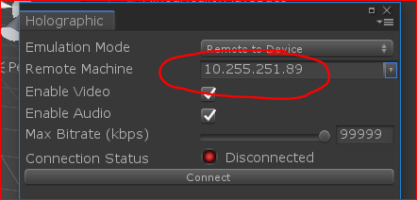

1. Click **Connect**

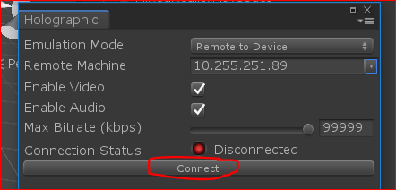

1. If there is green light, you are connected!
2. Place your **HoloLens** onto the **Mount** so that the top of the HoloLens so it looks like this:

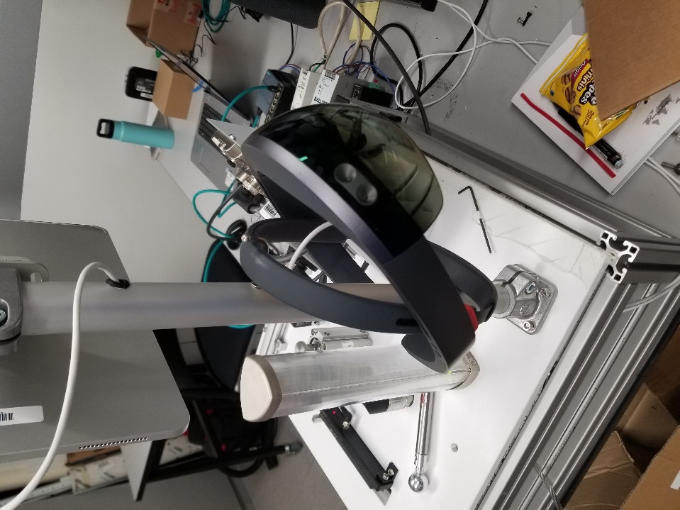

1. Now click the **Play** (→) button at the top of your UnityProject

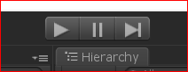

18. If this happens, your Counter is all ready to go on the software end! Well done!

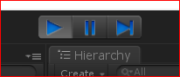

19. Start interacting with your objects in Unity with the ***Select*** and ***Flower*** hand gestures

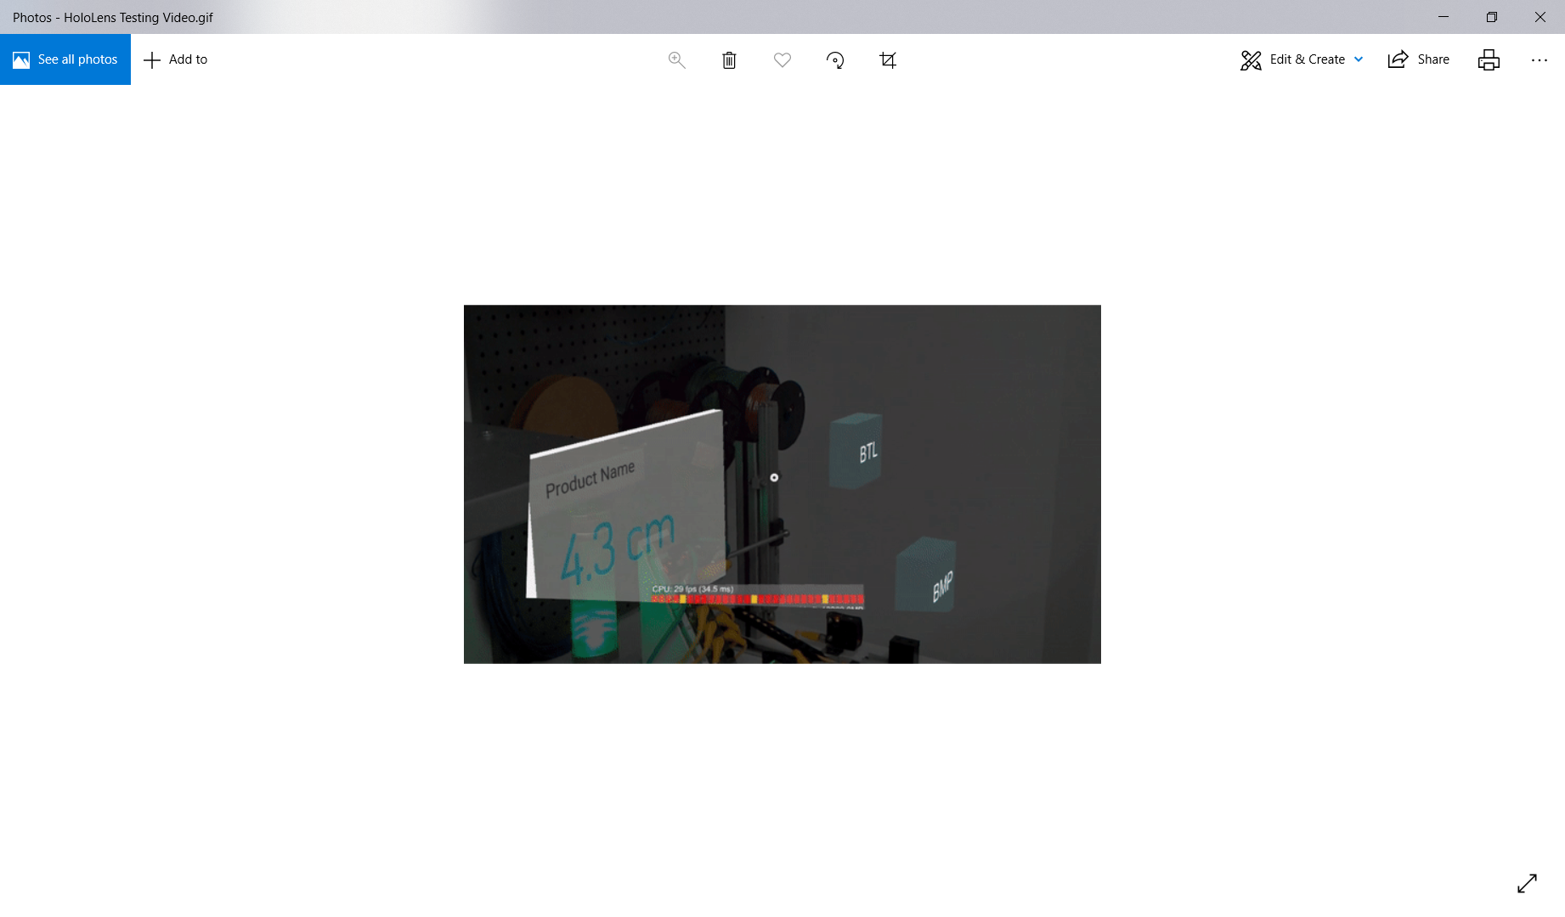

# Errors

Step 13:

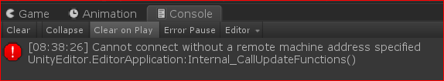

Make sure that your HoloLens is turned on

Step 14:

If there is a yellow light, make sure that your Wi-Fi is the same as your computer